CRX How To: WebRefill

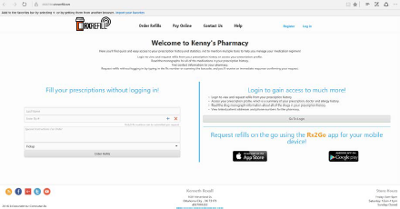
There are two ways for a patient to activate a WinRxRefill account and take advantage of the account’s additional features.
1) A patient can request an account activation from the WinRxRefill page.
2) The pharmacy can activate the customer from within WinRx.
Step 1 instructions:
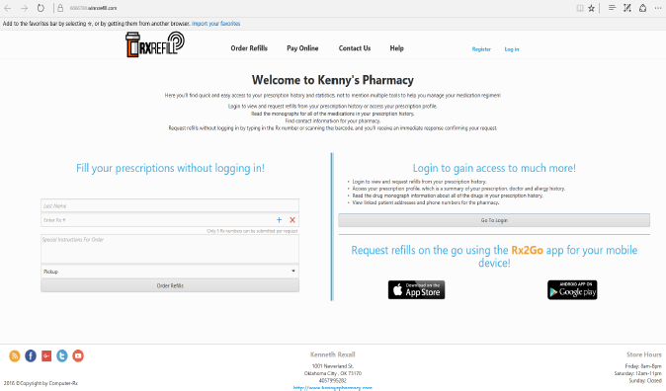
WinRxRefill Account Online Setup: A patient can begin the process of sending a pending request to the pharmacy by selecting “Register.”
Note: The prompt defaults to the last name of the account, guiding the patient name search, but can be typed into like any other search field. (Family last names may be different)
Next:
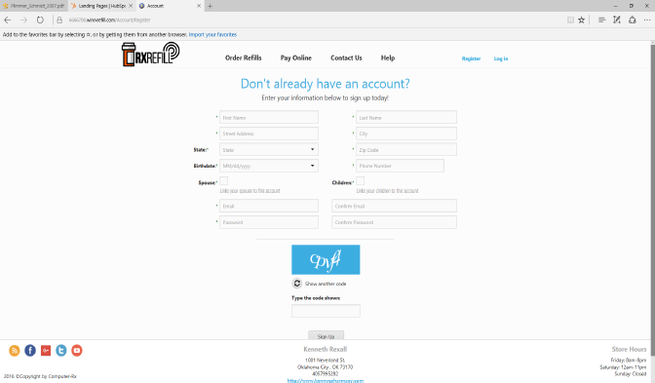
The patient will input their personal information, the security code, and click on “Sign Up.” This will send the pending request to the pharmacy for approval.
Next:
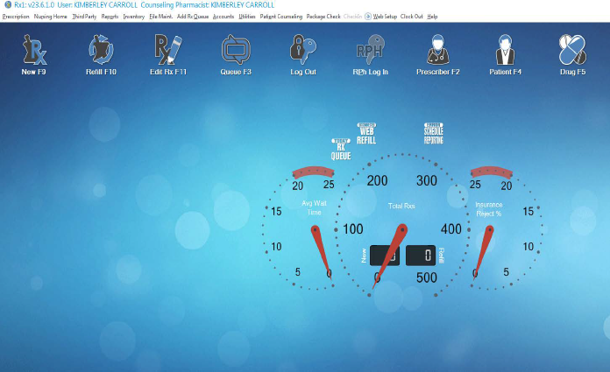
When a pending request has been received, WinRx will display an action arrow to alert the pharmacy next to the “Web Setup” menu.
Next:
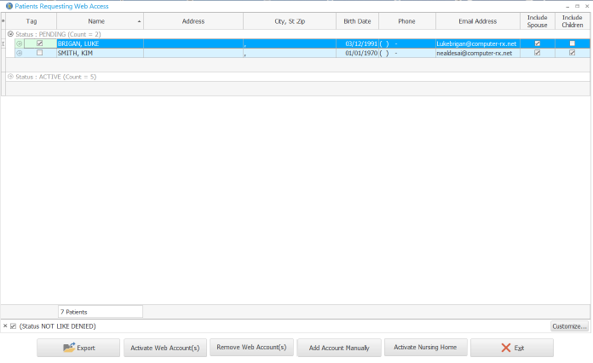
To approve a pending request, tag the desired account and select “Activate Web Account(s).”
Next:
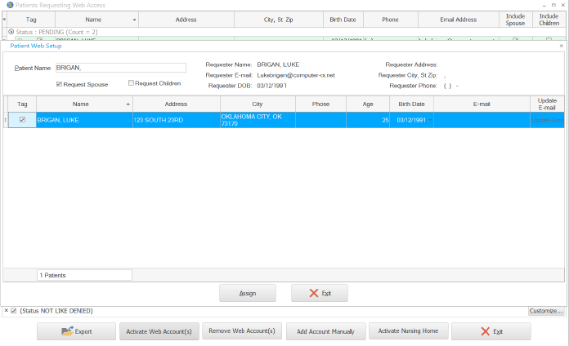
After selecting “Activate Web Account(s)” a box will appear with a patient pick list. Tag the correct patient and click on “Assign.” The patient’s spouse and children can be attached to the account at this time if desired.
Also:
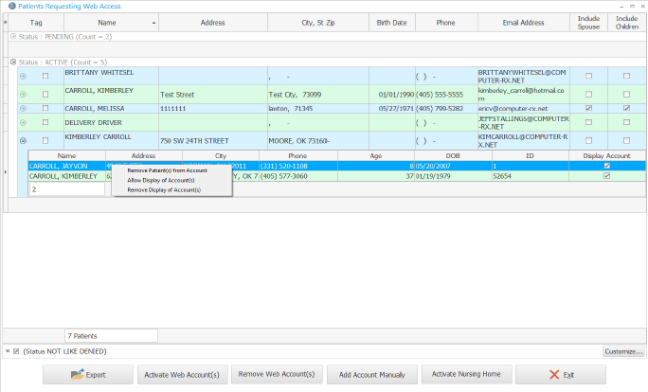
When a WinRxRefill account has multiple patients linked, the user has the ability with a right click to modify the account setting.

Step 2: Manually setting up customer accounts
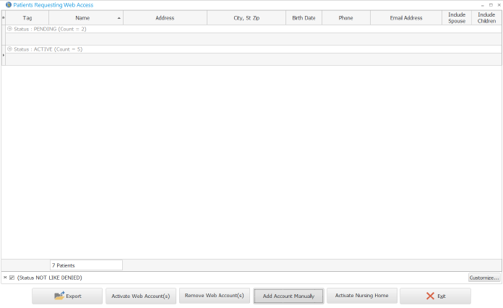
In-Store Patient Setup: When adding an account through WinRx, navigate to “Web Setup◊Patient Setup” and select “Add Account Manually.”
Next:
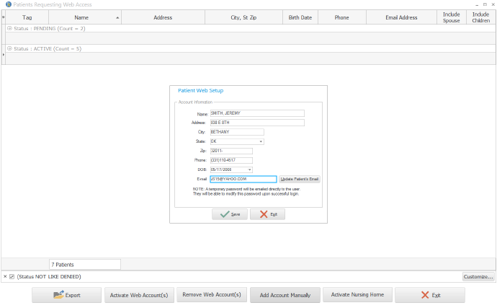
In the “Name” field, search and select the patient from the WinRx patient pick list. Input their email address if not populated and click “Save.” This will send an enrollment email to the e-mail address listed.
Then, the patient will then retrieve the email and click “this link” to activate and create a personalized password for the account.

Activate a Group
1. Make sure all patients are added to the group. (The group and patients should not be marked as grouping only).
2. Go to the Web Setup menu, then Patient Setup.
3. Click on "Activate Group."
4. Click on the drop down and select the group.
5. Populate all group information.
5. Click Save.
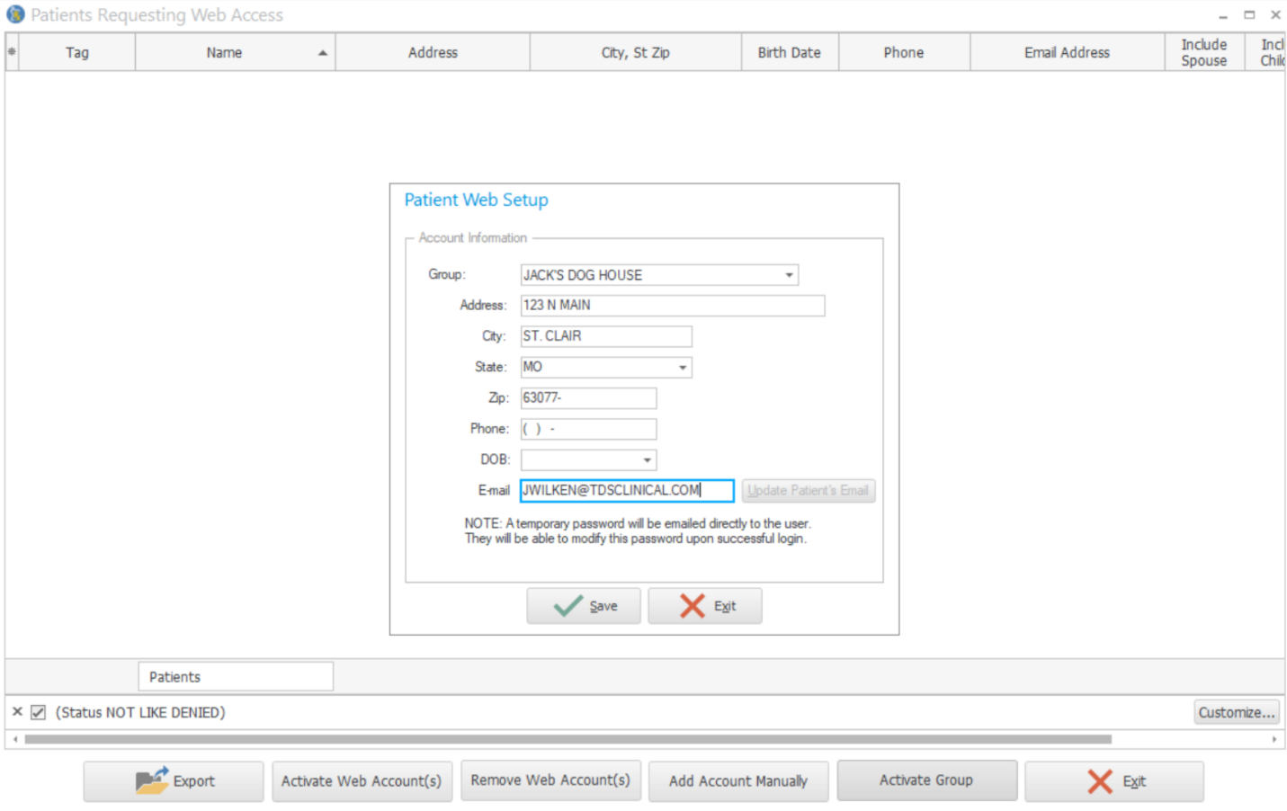

Removing Web Account
1. Tag the account.
2. Select Remove Web Account(s).
3. Select Yes.
